# 

# **AD3301-DATA EXPLORATION AND VISUALIZATION**

# **MINI PROJECT**

# **TIME SERIES ANALYSIS FOR UNIVARIATE,BIVATIATE,MULTIVARIATE VARIABLE**

# Time series analysis for univariate, bivariate and multivariate variable

# UNIVARIATE ANALYSIS:

# importing dataset

import pandas as pd

import numpy as np

import matplotlib.pyplot as plt

df=pd.read_csv('/content/smartphone.csv')

df.info()

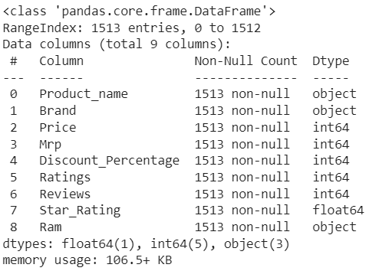

df.head(5)

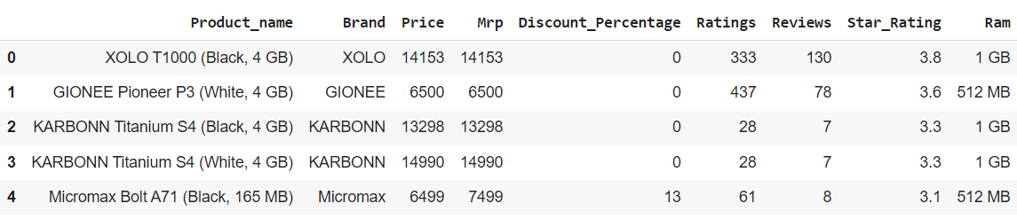

df.isnull()

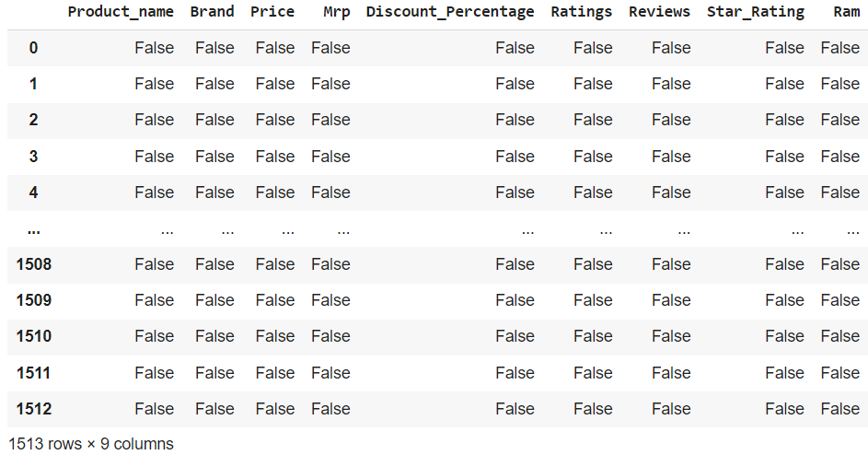

df.dropna()

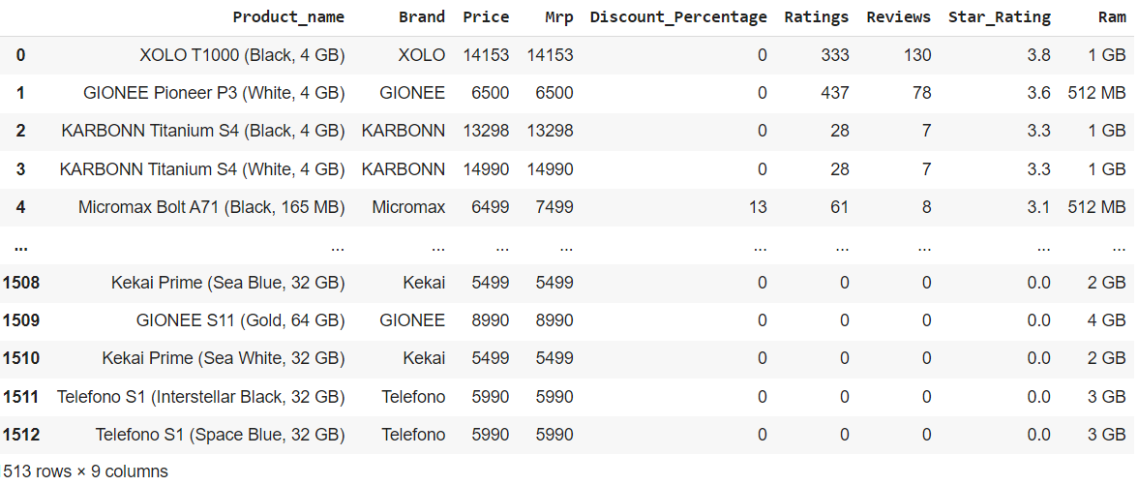

df.Product_name.value_counts().nlargest(30).plot(kind='bar', figsize=(14,8))

plt.title("Smartphones")

plt.ylabel('Number of smartphone')

plt.xlabel('Name of the smartphone')

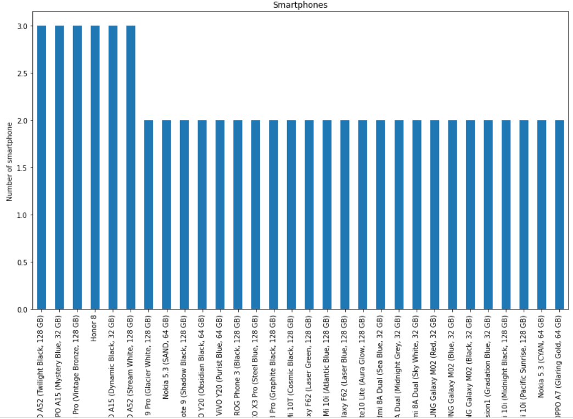

INSIGHT:

Oppo, Redmi and Honor are the most used smartphones.

# DESCRIPTIVE STATISTICS

#standard variance of dataset using std() function

std_dev =df.std()

print(std_dev)

# standard variance of the specific column

sv_Price=df.loc[:,"Price"].std()

print(sv_Price)

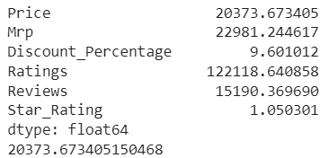

# variance of dataset using var() function

variance=df.var()

print(variance)

# variance of the specific column

var_Price=df.loc[:,"Price"].var()

print(var_Price)

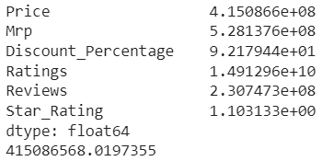

df.skew()

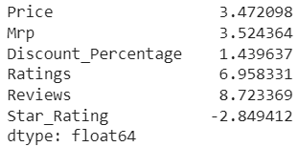

INSIGHT:

Star_Rating has negative skew

kurtosis =df.kurt()

print(kurtosis)

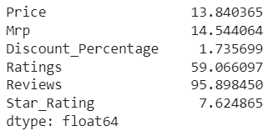

INSIGHT:

Platykurtic-Discount_percentage

All others have leptokurtic.

# GROUPING

double_grouping = df.groupby(["Product_name","Brand"])

double_grouping.first()

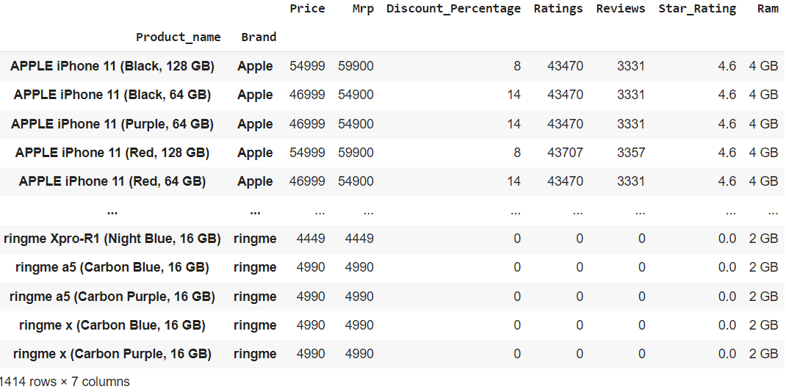

INSIGHT:

All the numerical datas are grouped together.

df.groupby('Brand').groups.keys()



INSIGHT:

All the brands of smartphones are listed as dictionary

style = df.groupby('Brand')

style.get_group("Google")

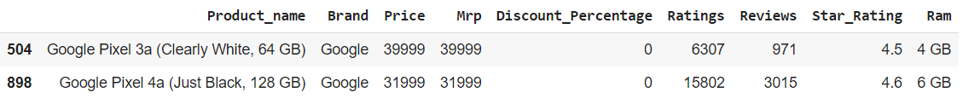

INSIGHT:

All the products of google along with their price, mrp, discount, reviews, star ratings and ram are shown.

style['Mrp'].max()

style['Mrp'].min()

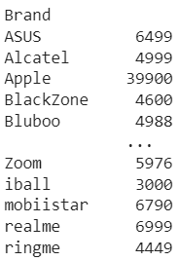

INSIGHT:

ASUS has the highest market value and ringme has the least.

style.mean()

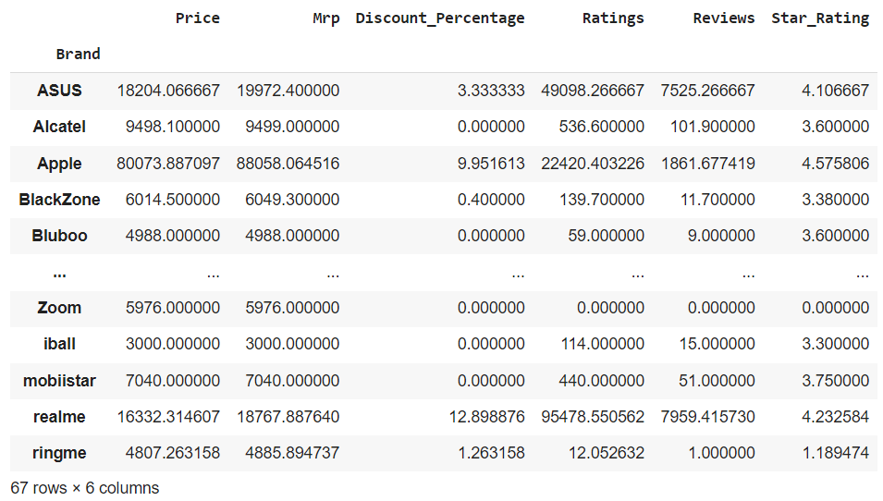

INSIGHT:

Mean of numerical column in each group is shown.

# Data aggregation

# new dataframe that consist length,width,height,curb-weight and price

new_dataset = df.filter(["Discount_Percentage","Ratings","Reviews","Star_Rating","Ram"],axis=1)

new_dataset

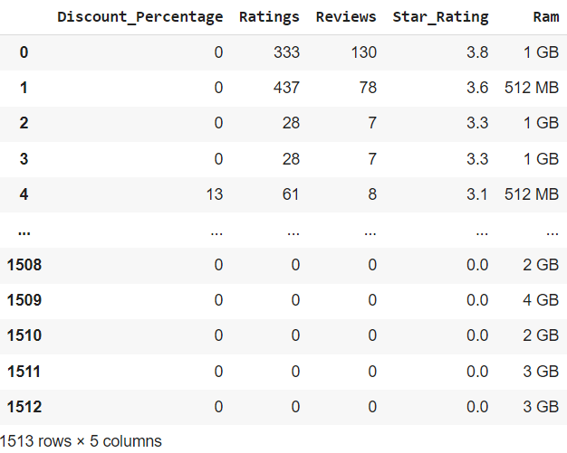

INSIGHT:

Numerical variables are grouped together.

new_dataset.agg("mean", axis="rows")

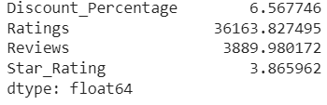

INSIGHT:

Average star ratings given is 3.865962

new_dataset.agg(['sum', 'min','max'])

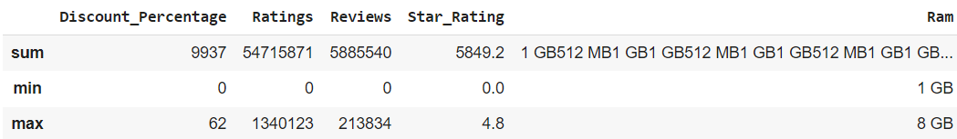

INSIGHT:

Minimum RAM speed of smartphone is 1GB and maximum is 8GB.

pd.crosstab(df["Brand"], df["Star_Rating"])

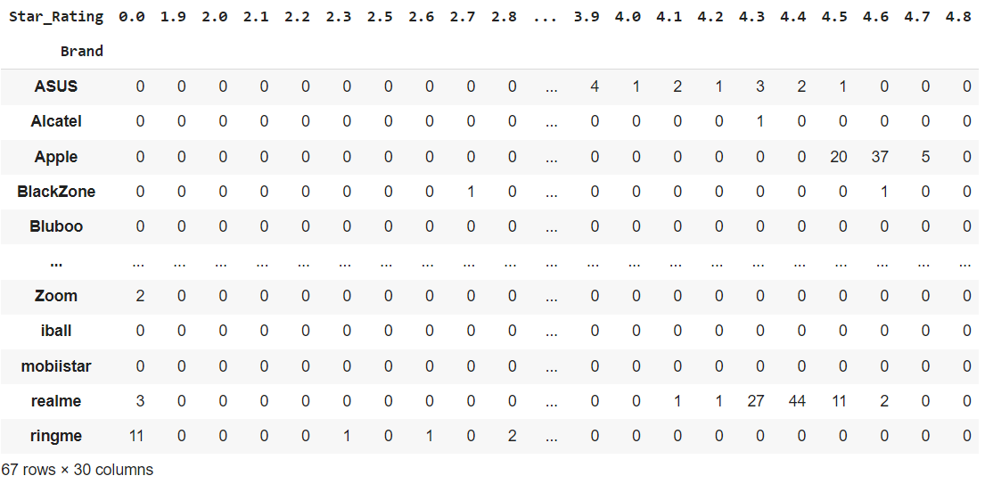

INSIGHT:

ASUS is having more than 4 star rating which could be seen from crosstable.

# CORRELATION

## UNIVARIATE ANALYSIS

#distribution plot

import seaborn as sns

sns.FacetGrid(df,size=5).map(sns.distplot,"Star_Rating").add_legend()

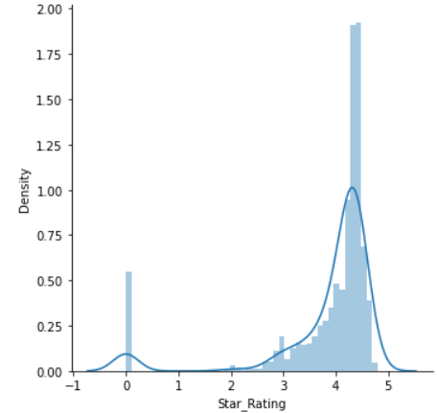

INSIGHT:

Maximum star rating is around 4.5.

#boxplot for albedo

sns.boxplot(x="Price",data=df)

plt.show()

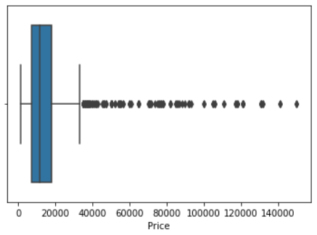

INSIGHT:

Maximum smartphones have the price of 20000.

import seaborn as sns

sns.histplot(x='Ram', data=df)

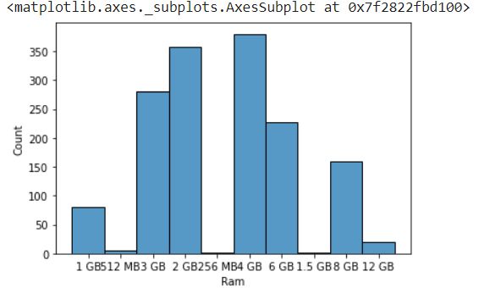

INSIGHT:

Maximum smartphones have the RAM speed of 4GB.

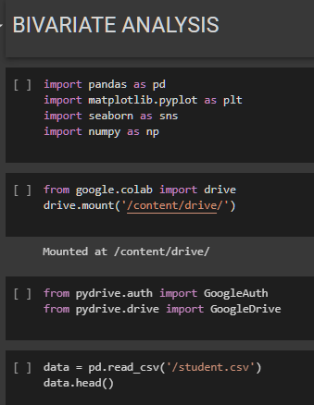

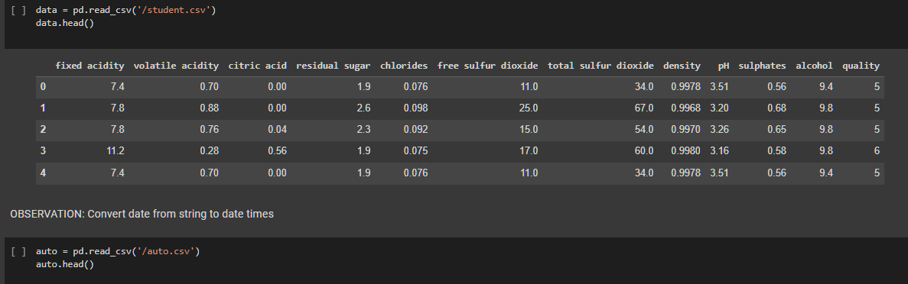

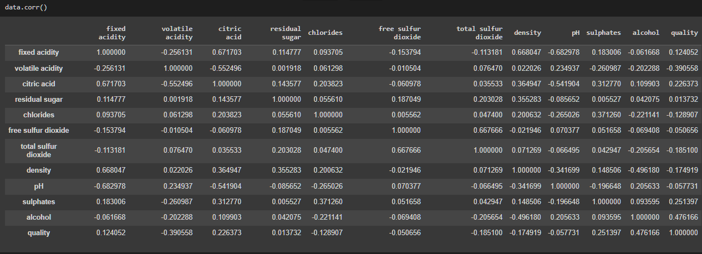

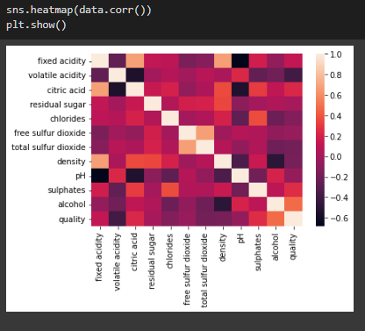

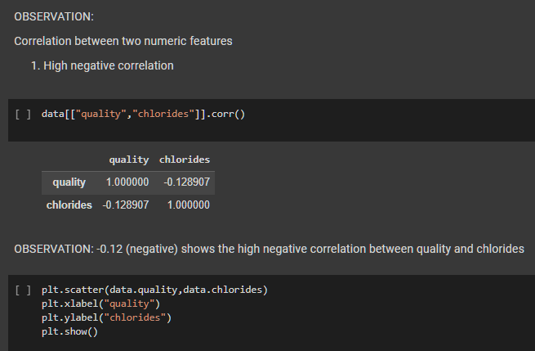

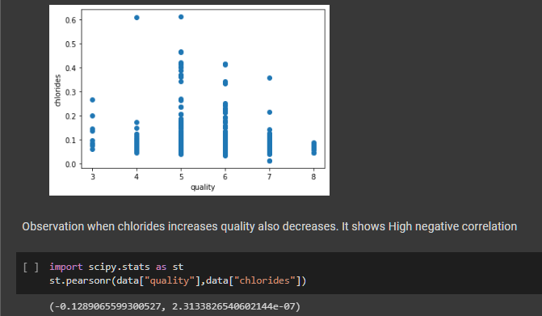

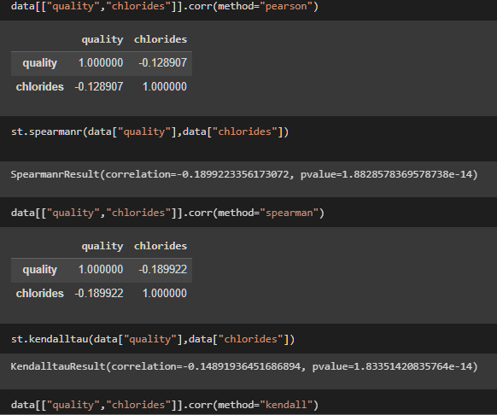

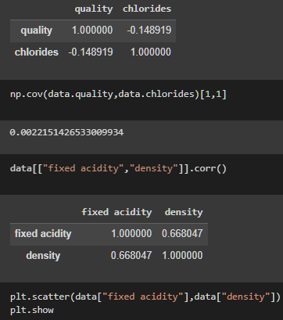

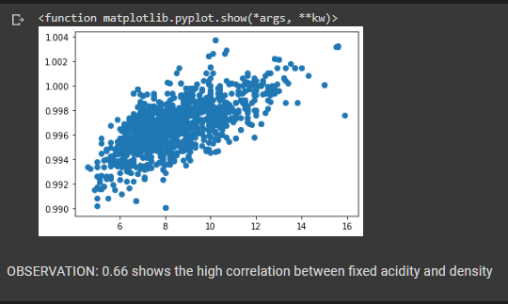

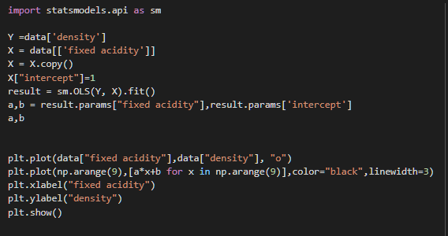

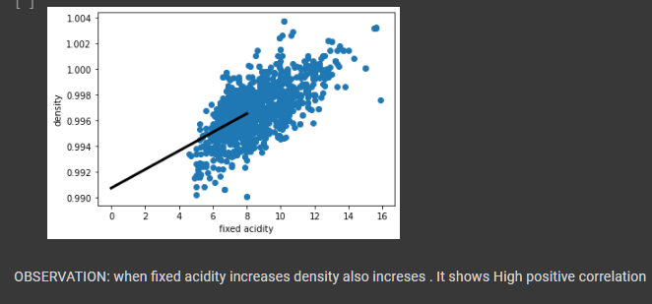

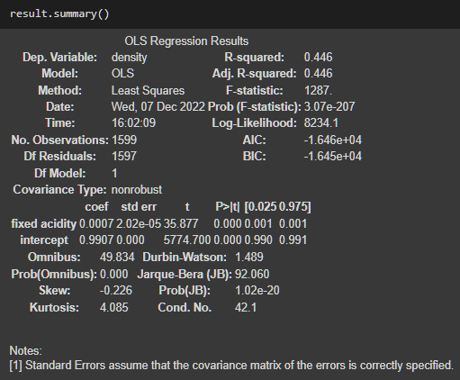

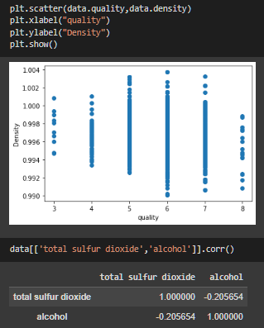

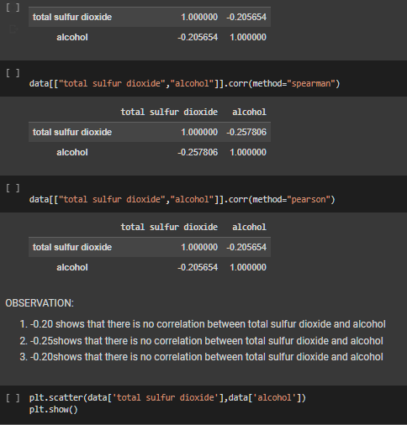

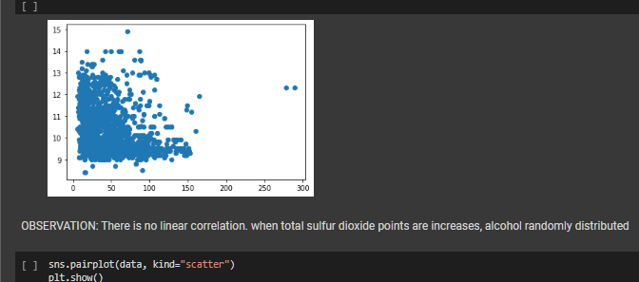

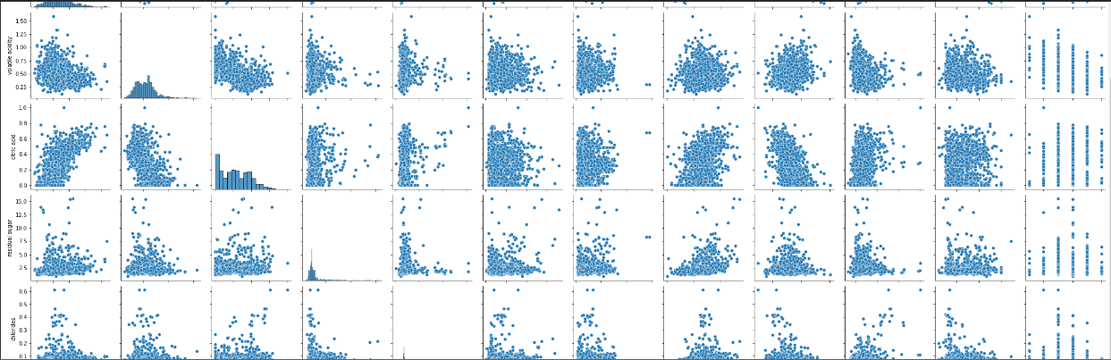

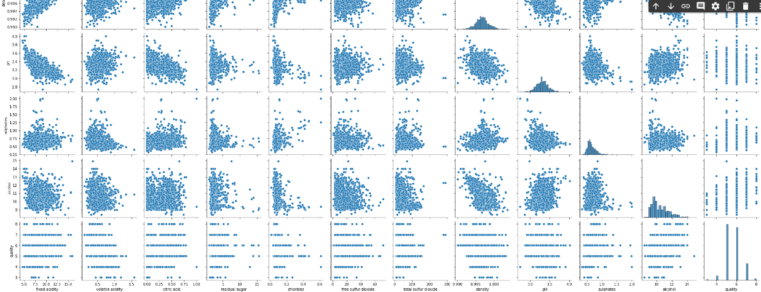

OBSERVATION: this is the scatter plot for my student dataset

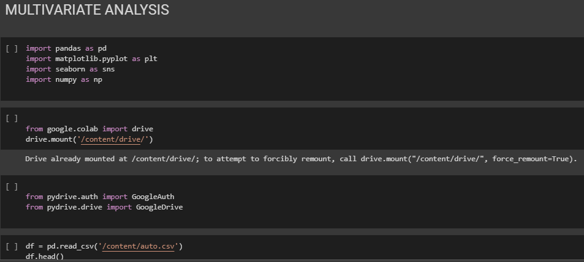

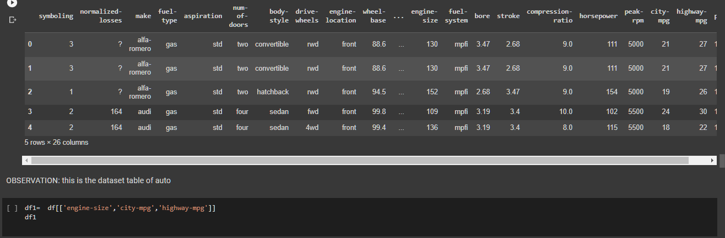

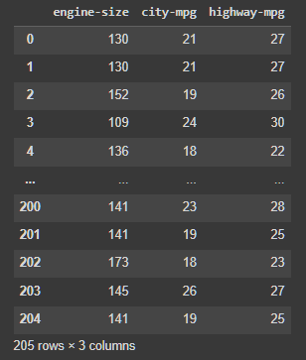

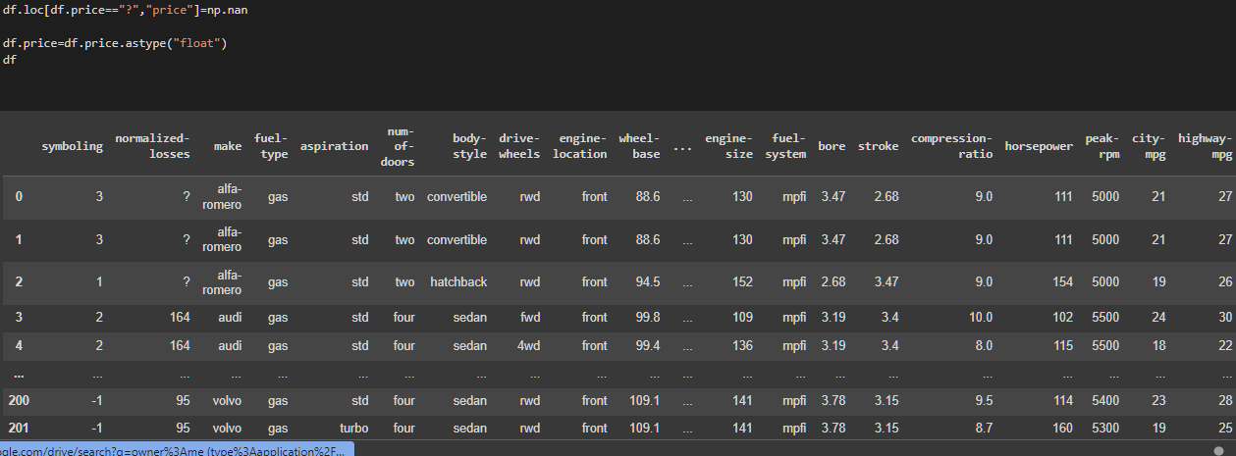

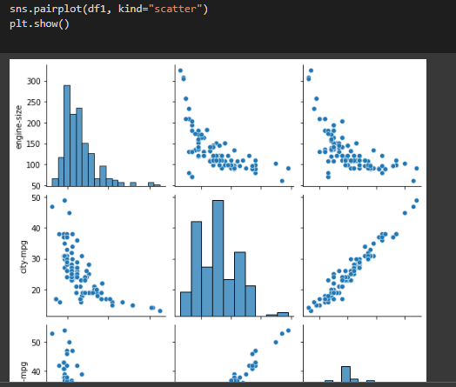

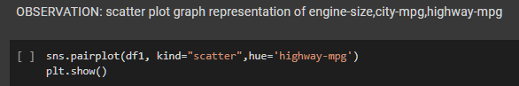

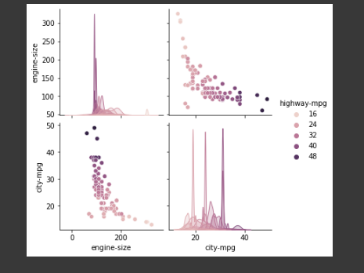

OBSERVATION: this is the scatter plot graph representation of engine-size and city-mpg then the colour represent the difference between highway-mpg

